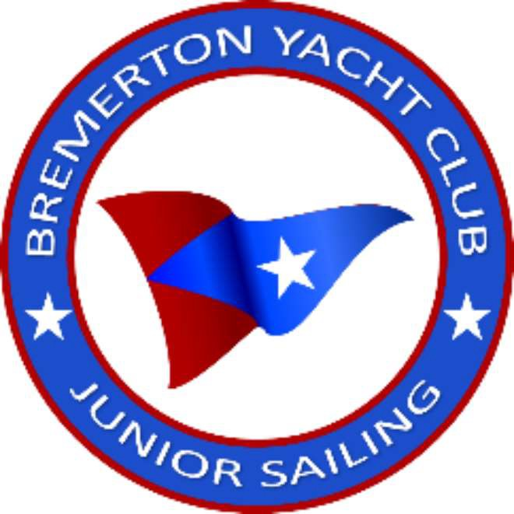Bremerton Yacht Club 2025 Junior Sailing Program – Parent’s Consent, Waiver of Liability,

Assumption of Risk and Indemnity Agreement

I, the undersigned parent or legal guardian (hereafter referred to as the Parent) of (hereafter referred to as the "Child"), request that my Child be allowed to participate in the Youth Sailing Program (the Program) at the Bremerton Yacht Club (the Club). This agreement shall remain in effect until the Club receives written notice of the cancellation of this Consent or until the end of the Program. In return for the Child being permitted to take part in the Program and to use the facilities and property of the Club I make the following promises and warrant the truth of the following facts.

1. I am familiar with the Program offered and the starting and ending times of each day's session. I understand that officers and employees of the Club are available to discuss the program if I should wish additional information. I understand that I am solely responsible for the arrival and departure of my Child at the beginning and end of each day's session. I will not allow my Child to remain on Club premises after the day's session without appropriate supervision or the written permission of the Club. I agree that the Club will have no responsibility for the supervision of my Child at times other than during scheduled sessions. I understand the importance of regular attendance as each day builds on the prior day's learning.
2. I will inform my Child that he/she is expected to cooperate with and follow the directions of the instructors in charge of the program, to act in a manner consistent with the spirit of good sportsmanship, and to respect the rights of others.
3. I certify that my Child is in good health and I know of no reason why he/she would be incapable of participating in the Program. My Child knows how to swim. I will immediately notify the Club if there is a change in my Child's ability to participate in the Program.
4. **WAIVER OF LIABILITY:** I waive and release any right I, my heirs, distributees, guardians, legal representatives and assigns may have or acquire to make a claim against, sue, attach the property of or prosecute the Club or any of its members, directors, officers, agents, employees and affiliated organizations (herein referred to as "the releases") for monetary damages caused by injury to my Child or damage to the property of my Child or myself arising from my Child's participation in the Program and use of the facilities and property of the Club, whether or not the injury or damage results from the negligence or other action, except intentional acts, of any of the releasees. (Please initial to indicate you have read this paragraph. / _)
5. **ASSUMPTION OF RISK:** I am aware that the Program may involve maneuvering a boat on cold, deep waters in potentially hazardous conditions. These hazardous conditions may include, among other things, strong winds and high waves, sudden and unexpected immersion in cold, deep water and collision with other watercraft or stationary objects such as docks, pilings and buoys. With knowledge of the dangers involved, I voluntarily ask that my Child be allowed to take part in the Program. I ACCEPT ANY AND ALL RISKS TO MYSELF AND MY CHILD OF INJURY OR DEATH, AND PROPERTY DAMAGE ARISING FROM PARTICIPATION IN THE PROGRAM AND THE USE OF THE FACILITIES AND PROPERTY OF THE CLUB, WHETHER OR NOT CAUSED BY THE NEGLIGENCE OR OTHER ACTION, EXCEPT INTENTIONAL

ACTS, OF ANY OF THE RELEASEES. (Please initial to indicate that you have read this paragraph. / _)

1. **INDEMNITY AGREEMENT:** I agree to indemnify and hold the releasees harmless from any loss, liability, damage or cost, including reasonable attorney's fees, that may incur due to my Child's participation in the Program and use of the property and facilities of the Club, whether or not such loss, liability, damage or cost results from the negligence or other action, except intentional acts, of any of the releasees. (Please initial to indicate you have read this paragraph.

*I* _)

I HAVE CAREFULLY READ THIS AGREEMENT AND FULLY UNDERSTAND ITS CONTENTS. I AM AWARE THAT THE AGREEMENT INCLUDES A WAIVER OF LIABILITY, AN ASSUMPTION OF RISK AND AN AGREEMENT BY ME TO INDEMNIFY THE RELEASEES, AND I SIGN IT OF MY OWN FREE WILL.

Parent's Signature: Date: Printed Name: